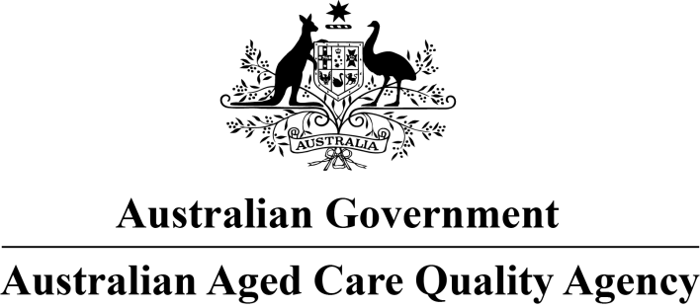

Consumers’ Experience of the Quality of Care and Services: Aged Care Homes
Calvary Mt Carmel Retirement Community
RACS ID: 0334
Re-accreditation audit dates: 12 December 2017 to 13 December 2017
An audit team from the Australian Aged Care Quality Agency visited the aged care home for re-accreditation purposes and spoke to at least 10 per cent of the people who live there. Those we interviewed for this report were randomly selected. The results are presented in this report which will help you understand the experience of consumers living in the home. It should be read alongside the accreditation audit report on the home available at the Quality Agency's Accreditation Report Search page. For more general information on aged care, visit the My Aged Care website.
Number of consumers interviewed: 12
Number of representatives interviewed: 2

What is your experience at the home?
- Do staff treat you with respect?
100 per cent of respondents say staff treat them with respect most or all of the time.
- Do you feel safe here?
100 per cent of respondents say they feel safe most or all of the time.
- Do staff meet your healthcare needs?
100 per cent of respondents say staff meet their healthcare needs most or all of the time.
- Do staff follow up when you raise things with them?
92 per cent of respondents say staff follow up when they raise things with them most or all of the time.
- Do staff explain things to you?
93 per cent of respondents say staff explain things to them most or all of the time.
- Do you like the food here?
93 per cent of respondents say they like the food most or all of the time.
For the following questions, to what extent do you agree with these statements?
- If I’m feeling a bit sad or worried, there are staff here who I can talk to.
64 per cent of respondents agree or strongly agree that if they are feeling a bit sad or worried, there are staff here they can talk to.
- The staff know what they are doing.
93 per cent of respondents agree or strongly agree that the staff know what they are doing.
- This place is well run.
86 per cent of respondents agree or strongly agree that this place is well run.
- I am encouraged to do as much as possible for myself.
93 per cent of respondents agree or strongly agree that they are encouraged to do as much as possible for themselves.

http://www.aacqa.gov.au/publications/reports
http://www.myagedcare.gov.au

