COVID-19 Keeping Yourself Safe
This storyboard is designed to explain the steps you can take to protect yourself from COVID-19. This is important as COVID-19 can be more serious for some older people.
Frame 1: You may have a higher risk of developing complications from COVID-19 if you:
- are over the age of 70;
- are of Aboriginal or Torres Strait Islander background;
- have diabetes or other chronic health conditions such as renal failure; or
- have respiratory weakness.
The best way to stay safe is to minimise your risk of picking up the virus.
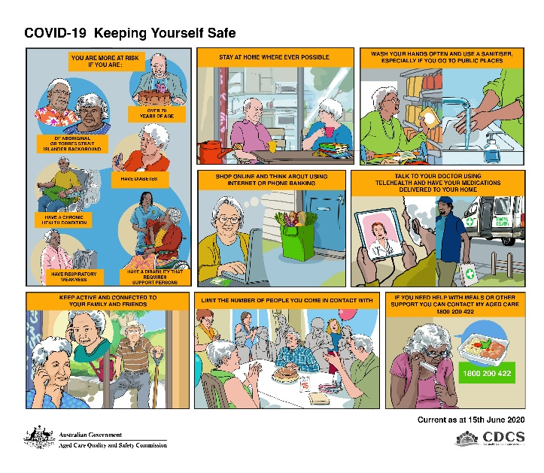
Frame 2: Stay at home as much as possible. This means you will be minimising the number of people you come into contact with who could be carriers of the virus.
Frame 3: When you do go out shopping take precautions. Try to go out when it is quieter as there will be less people around. Write up a shopping list before you go out and take it with you so that you can get what you need quickly. This will help to ensure you can spend less time in areas that might be a higher risk to you.
Use a card to pay for items rather than cash as there is less chance of touching infected coins or notes. Have a small bottle of sanitiser in your bag and use it to disinfect your hands when you leave the store. Wash your hands well after you get home and after packing away your groceries.
Frame 4: If you are at high risk, consider using internet shopping and banking services rather than going out. If you need help to set this up, talk to your aged care service provider or contact My Aged Care for a referral for support.
Frame 5: You can also talk to your Doctor using telehealth services if you have a smart device. You can also arrange to have your medications delivered to your door. If you need some assistance accessing smart devices you can call My Aged Care for support.
Frame 6: It’s important that you stay connected to your friends, family and community. You can do this by calling or using platforms like Facetime and Skype for video calls. You can also stay active by taking walks around your neighbourhood or by working in your garden.
Frame 7: While the virus is still around in our community we all need to limit the number of people we come in contact with as much as possible. Family celebrations are important, but where possible you should reduce the number of people in attendance. Where people are not living in the same household make sure that you maintain a safe distance from each other when you come together.
Frame 8: If you need support to stay safe at home such as getting delivered meals, accessing smart devices or personal safety alerts and alarms, get in touch with My Aged Care on 1800 200 422, they may be able to help.

