



Choice, dignity, respect – older people’s rights in aged care
  - Stakeholder Toolkit

May 2026

About this toolkit
The Aged Care Quality and Safety Commission is the national regulator of Government funded aged care services. It is our role to uphold the rights of older people and protect and enhance their safety, health, wellbeing and quality of life.
Our regulatory functions include listening to the experiences of older people and supporting them to be informed about their aged care rights. We also support and educate providers and workers about those rights and their obligations in meeting them.
We are running a public information program to ensure older people, their families and supporters understand that stronger rights and protections exist under the Aged Care Act 2024. A video provides an overview of the program.
We know that older people and supporters are more likely to raise concerns with their provider when they feel reassured that:
- it is safe to speak up and they know who they can speak to
- they will be listened to and taken seriously
- raising a concern will not negatively affect their care.
Our public information program is about reaffirming to older people and their supporters that they can feel safe to raise concerns and give feedback directly with their provider, and to trust they will be listened to with respect.

This toolkit has been developed for peak bodies and advocacy groups with information and resources to support your members in engaging with older people, their families and supporters about key topics including:
- the rights of older people in aged care
- raising concerns when something doesn’t feel right
- the role of the provider in supporting older people to speak up
- the role of the Commission and Aged Care Complaints Commissioner.
We have also created materials to help communicate this information through your channels, including newsletter copy, social media posts and links to videos and resources.

What’s in this toolkit?
- Key messages
- Webpages
- Social media copy and tiles
- Editorial copy
- Resources
  - For providers and workers
  - For older people and their supporters
- Videos
Call to action
You can promote the messaging and resources in this kit to your members, older people and their supporters, provider and workers, via:
- social media
- newsletters
- notice boards (as relevant)
- making hard copy resources available in appropriate locations or via community settings.
When sharing materials we recommend the below calls to action:
- talk to your members and to older people receiving aged care about the Statement of Rights and what they mean in practice
- encourage them to watch the video explaining the Statement of Rights – introduction for older people or Rights-based complaints handling – an overview by the Aged Care Complaints Commissioner
- remind them of the importance of older people and their supporters feeling safe and supported to speak up if they have a concern and ensure they understand their provider’s complaints process
- explain that support is available via the Older Persons Advocacy Network and the Aged Care Quality and Safety Commission.
Diverse audiences
We recognise that older people from diverse cultural, linguistic and life backgrounds may have unique needs and preferences. Their background and experience impacts on how they access and engage with aged care supports. This includes differences in language, traditions, identity and family structures.
We are committed to making sure our information is inclusive, culturally safe and responsive. Every older person should feel safe, understood, respected and able to make choices that reflect who they are. If someone has difficulty speaking or understanding English, there are interpreting services to communicate in their preferred language.

If you would like any of our resources that are not currently translated, please contact us at communications@agedcarequality.gov.au.
We have developed dedicated information and resources to help First Nations older people understand their rights in aged care and support providers and workers to provide good, culturally safe aged care. You’ll find these on the First Nations Hub on our website.
Translating and interpreting services
We can arrange interpreters for anyone who needs assistance in a language other than English when contacting the Commission. The below services can also assist when contacting the Commission:
- Translating and Interpreting Service (TIS) – 131 450
- Aboriginal Interpreter Service (AIS) – 1800 334 944
- Aboriginal Interpreting Western Australia – 08 9192 3981
Our document Translated information for people receiving aged care poster has information in different languages about how to contact the Commission using an interpreter and is available for download.
The National Relay Service provides support for people who have a hearing or speech impairment:
- TTY users: call 1800 555 677 then ask for the Commission’s number 1800 951 822
- Speak and Listen users: call 1800 555 727 then ask for the Commission’s number 1800 951 822
- Internet relay users: connect to the National Relay Service and enter 1800 951 822.
Sign language interpreting and captioning services

The National Sign Language Program (NSLP) provides free sign language interpreting and captioning services through Deaf Connect for eligible older people.

The NLSP can help with:
- using aged care services and taking part in professional and social activities
- health and medical appointments that are covered by Medicare.

To make a booking, call 1300 773 803, email interpreting@deafconnect.org.au or go to the Deaf Connect website.

Orderable resources and translated materials
The materials in this information kit are available in digital and hard copy format. You can find all the resources listed in this provider information kit on our website.

If you require hard copies of any of these resources, or if you’re looking for translated materials, you can order them via our orderable resources page.

Key messages
You can use the following key messages when engaging with older people, their families and supporters about rights and raising concerns.
- Older people now have stronger rights and protections following recent changes to aged care laws in Australia.
- These changes include a Statement of Rights for older people receiving aged care services. They include the right to make their own decisions, to be respected and to feel safe.
- Older people also have the right to communicate their needs and preferences, to have their culture and identity respected, and to stay connected with their community.
- If an older person has a concern about their aged care services, they have the right to speak up.
- They can talk to their provider first. Their provider must respect their rights and have a complaints process that is easy to understand and use. Their provider can’t punish them or treat them differently for raising a concern.
- They can choose to have a family member or supporter raise a concern on their behalf.
- If older people need help making a complaint or finding information, they can contact the Older Persons Advocacy Network (OPAN) for free, independent, and confidential support. ​Call the Aged Care Advocacy Line on 1800 700 600.
- If an older person prefers, they can contact the Aged Care Quality and Safety Commission directly to make a complaint or give feedback.
- The new Aged Care Complaints Commissioner works within the Commission to make sure every concern is handled in a way that is confidential, timely and fair.

Webpages
The following webpages provide key information for providers and workers, older people receiving aged care services and their supporters.
Choice, dignity, respect – your rights in aged care
Find out more about older people’s rights in aged care, provider obligations in supporting older people to raise their concerns and the role of the Aged Care Quality and Safety Commission.
How to raise a concern – for older people
Find out more about what older people can do if they have a concern, their rights and protections under the new Aged Care Act 2024, and how the Aged Care Quality and Safety Commission can help.
Good complaints practice – for providers
An overview of good complaints practice for providers including links to guides, fact sheets and our complaints handling checklist.
Make a complaint
Access the Aged Care Quality and Safety Commission’s online complaints form or find out more about making a complaint by phone or in writing.
Aged care complaints FAQs
Detailed answers to a range of questions about complaints, covering:
- how the Commission can help​ older people
- what older people should know before, during and after making a complaint​
- information for providers and workers​
- supports available for older people.
First Nations Hub
Information and resources for First Nations older people and providers and workers to ensure good, culturally safe aged care is provided.

Social media copy and tiles
We’ve developed a series of social tiles and copy to raise awareness about rights for older people in aged care, sharing feedback or making a complaint. Share these with your networks across your social media channels.
Channel | Copy | Social media tile
LinkedIn  Facebook | Older people have the right to make their own decisions, to be respected and to feel safe. The Aged Care Quality and Safety Commission is raising awareness about older people’s rights in aged care.  Everyone has the right to choice, dignity and respect and to feel safe, heard and supported.  Learn more at agedcarequality.gov.au or call 1800 951 822.  #ACQSC #Complaints #AgedCareQuality #AgedCareRights | Embed video: Rights-based and person-centred care – what it means for older people
LinkedIn  Facebook | Everyone has the right to choice, dignity and respect in aged care. The Aged Care Quality and Safety Commission is encouraging older people to speak up if something isn’t right in aged care.  If you have a concern, you can talk to your provider first.  You can also contact the Aged Care Quality and Safety Commission for independent information, feedback or complaints.  Visit agedcarequality.gov.au or call 1800 951 822.  #ACQSC #Complaints #AgedCareQuality #AgedCareRights | Embed image: https://www.agedcarequality.gov.au/media/102380  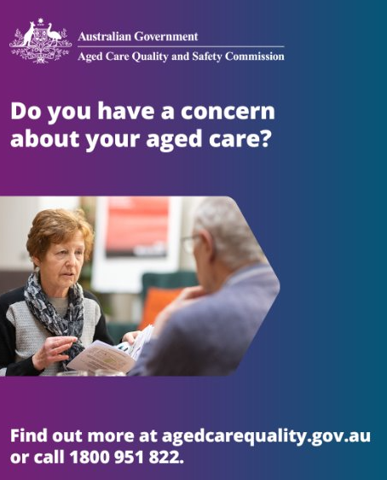
LinkedIn | Culturally safe care is your right. The Aged Care Quality and Safety Commission has created new resources to support First Nations providers, workers and older people understand their rights and obligations in ensuring First Nations older people get the good quality, culturally appropriate and safe aged care everyone is entitled to.  This video discusses the importance of cultural training for aged care workers to deliver good quality, culturally appropriate and safe aged care for Australian First Nations older people.  Choice, dignity, respect – your rights in aged care.  Find out more at agedcarequality.gov.au or call 1800 951 822.  #ACQSC #Complaints #AgedCareQuality #AgedCareRights | Embed video: Culturally safe care is your right
Facebook | Good aged care means you are safe and cared for in the right way. It means respecting your connection to family, your community and your Country.  New aged care laws include the Statement of Rights to help make sure everyone is getting good and safe aged care.  You can find more resources to support older First Nations people, their families and aged care workers and providers who care for them at agedcarequality.gov.au/FirstNations | Embed video: Your rights in aged care

Editorial copy
Use the newsletters articles below to promote the rights of older people receiving aged care and how they can raise a concern or make a complaint. There are two versions – one directed to providers and workers, and one directed to older people, their families and carers.

Provider and worker copy
Choice, dignity, respect – older people’s rights in aged care
Older people now have stronger rights and protections following recent changes to aged
care laws in Australia. These changes include a Statement of Rights for older people receiving aged care services.

They include the right for older people to make their own decisions, to be respected and to feel safe. Older people also have the right to communicate their needs and preferences, to have their culture and identity respected, and to stay connected with their community.

Aged care providers have an obligation to ensure that older people understand their rights and are encouraged to raise concerns. They must have a complaints process that is easy to understand and use. Good complaints practice can:

- fix problems quickly and early, and stop them from happening again
- improve quality of care
- help providers put the needs of older people at the centre of providing aged care
- increase satisfaction and improve relationships between the person receiving care, their family and supporters, the provider and workers.

If you notice something has gone wrong, talk to the person affected and try to resolve the issue before they make a complaint. This helps build trust and confidence in your service.

Older people in your care should be reminded that advocacy support is available through the Older Persons Advocacy Network (OPAN). OPAN provide information or support with government-funded aged care services, and their Aged Care Advocacy Line (1800 700 600) can provide free, confidential, and independent support.

The Commission has a range of information and resources to support providers and workers in understanding their obligations and improving their complaints practices. You can find out more at www.agedcarequality.gov.au.

Older people, families and supports copy
Choice, dignity, respect – older people’s rights in aged care
You now have stronger rights and protections following recent changes to aged care laws in Australia. These changes include a Statement of Rights that include the right to make your own decisions, to be respected and to feel safe.

You also have the right to communicate your needs and preferences, to have your culture and identity respected, and to stay connected with your community. The Statement of Rights recognises that everyone is an individual and your preferences and needs are unique to you.

If you have a concern about the aged care you or someone else is receiving, you can speak with your provider. This is often the easiest and quickest way to resolve things.

Your provider must respect your rights and have a complaints process that is easy to understand and use. You can ask a friend, family member or a supporter to help you raise a concern.

Advocacy support is also available through the Older Persons Advocacy Network (OPAN). If you require information or support with government-funded aged care services, OPAN’s Aged Care Advocacy Line can provide free, confidential, and independent support. You can speak with an advocate by calling 1800 700 600 or visit opan.org.au

The Aged Care Quality and Safety Commission
If you don’t feel comfortable talking to your provider or if speaking to your provider hasn’t helped, you can speak with the Aged Care Quality and Safety Commission. The Commission is the national regulator of Government funded aged care services.

They can help by:
- listening to you and explaining the rights of older people
- finding out what you’d like the provider to do differently
- explaining their role and how they can best help.

You can contact the Commission by:
- calling 1800 951 822 between 9am – 5pm Monday to Friday
- writing to Aged Care Quality and Safety Commission, GPO Box 9819, in your capital city
- emailing info@agedcarequality.gov.au​.
The Commission also has a range of information and resources available about raising a concern or making a complaint. You can find out more at www.agedcarequality.gov.au

Resources
The Commission has a range of information and resources available about raising a concern or making a complaint. You can find out more at www.agedcarequality.gov.au.

For providers and workers
Use these resources when talking to providers and workers.
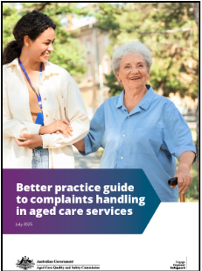  Better practice guide to complaints handling in aged care services | 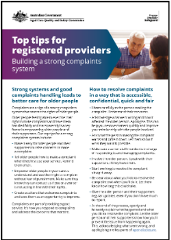  Top tips for registered providers: Building a strong complaints system | 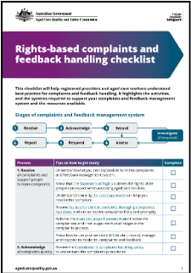  Complaints handling checklist
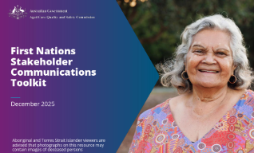  First Nations - Stakeholder Communications Toolkit | 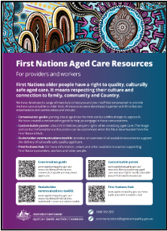  First Nations Aged Care Resources | 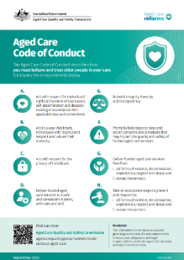  Aged Care Code of Conduct – responsible persons and aged care worker poster

For older people and their families
Use these resources by:
- promoting them on your website, in newsletters and social media
- making hard copies available at appropriate locations or via community settings.
You can order hard copies of the resources for older people (including translated versions) via our Order resources webpage.
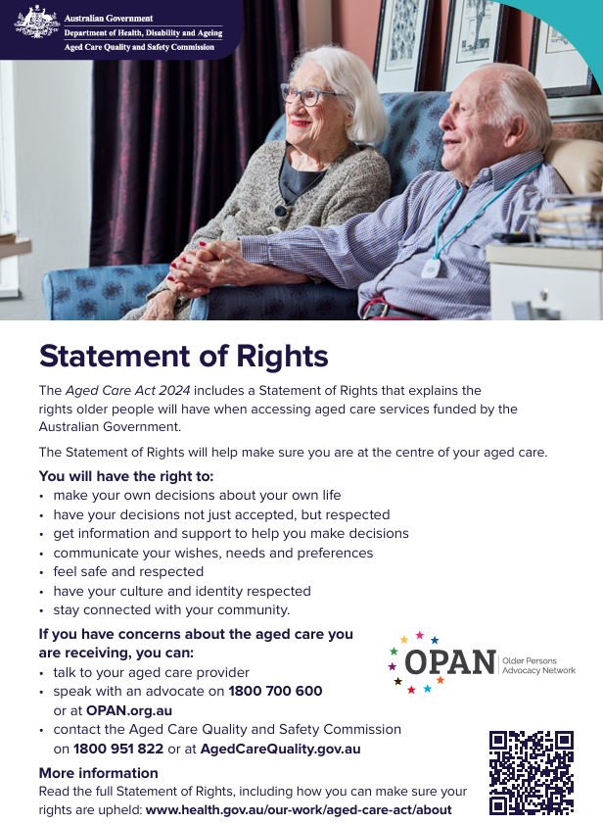  Fact sheet – Your rights in aged care | Poster – Your rights in aged care | 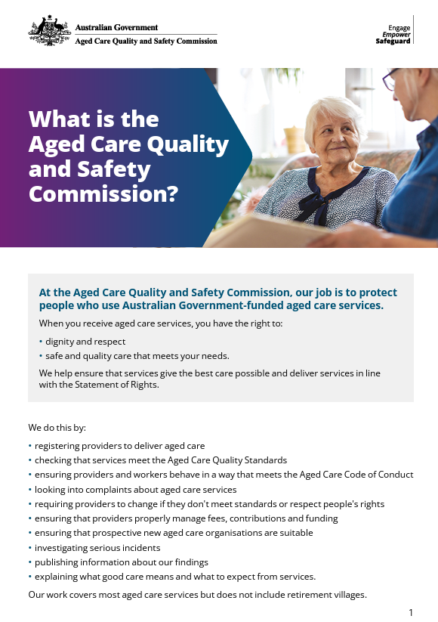  Fact sheet – What is the Aged Care Quality and Safety Commission
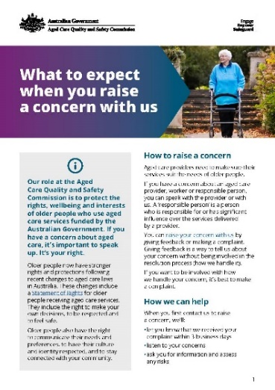  Fact sheet - What to expect when you raise a concern with us | 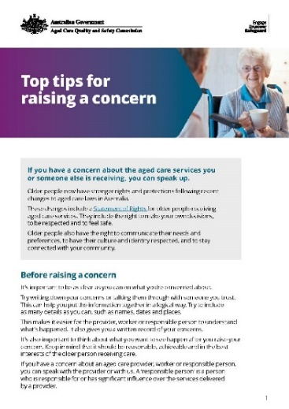  Fact sheet - Top tips for raising a concern | 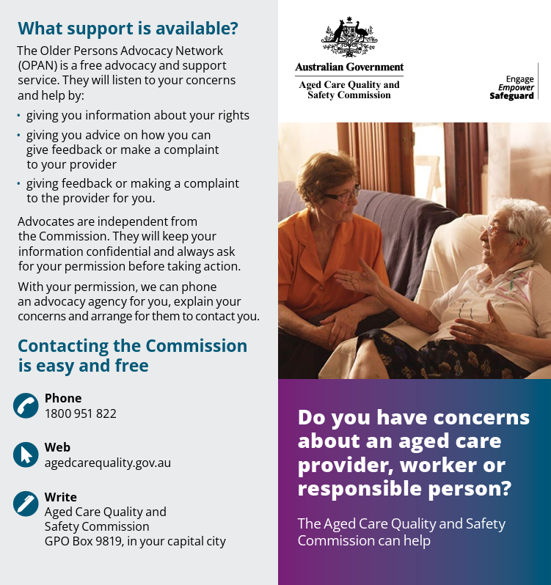  Brochure – Do you have concerns about an aged care provider, worker or responsible person
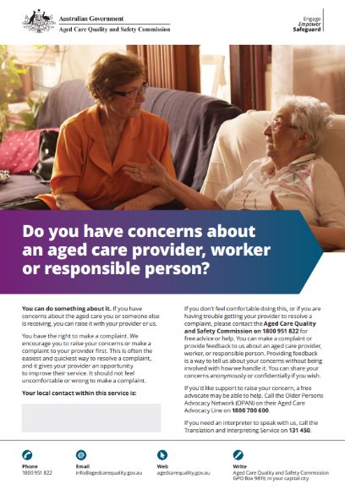  Poster – Do you have concerns about an aged care provider, worker or responsible person | 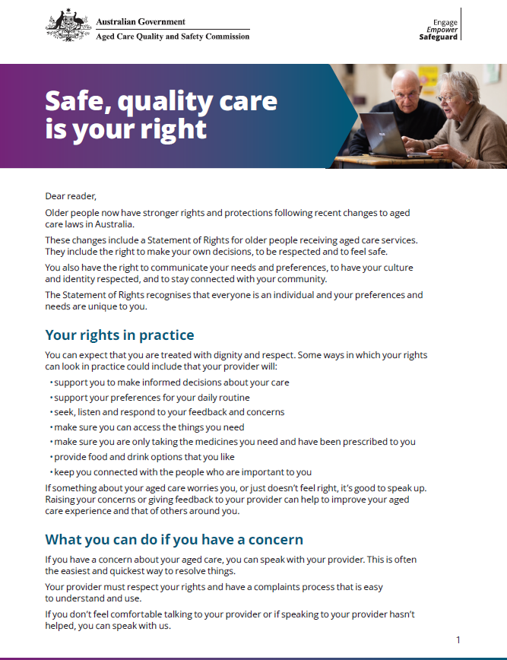  Letter from the ACQSC Commissioner and Aged Care Complaints Commissioner – Safe, quality care is your right | 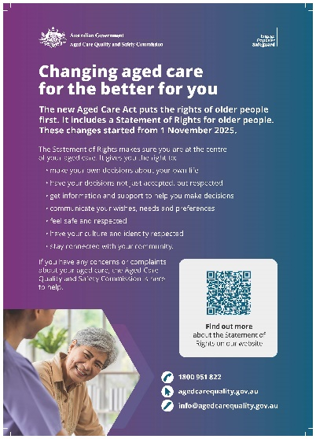  Poster – Diverse audiences: Changing aged care for the better
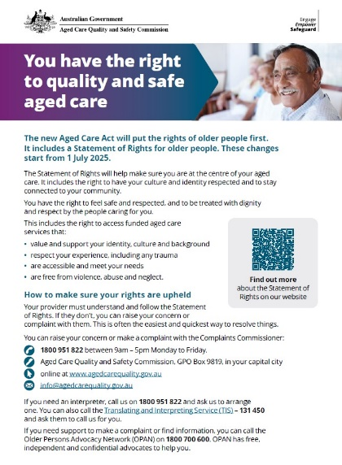  Fact sheet – Diverse audiences: You have the right to quality and safe aged care | 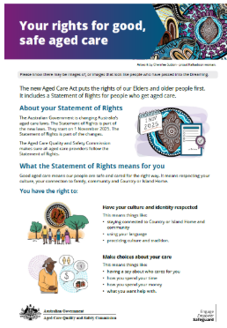  First Nations Statement of Rights Information Sheet | 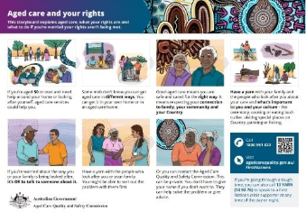  First Nations – Visual Storyboard – Aged care and your rights

Videos
Use these videos by promoting them on your website, in newsletters and on social media.
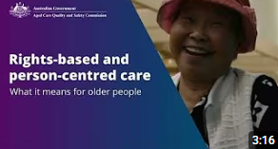  Rights-based and person-centred care – what it means for older people | 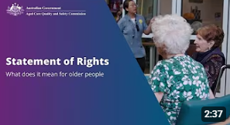  Statement of Rights – introduction for older people
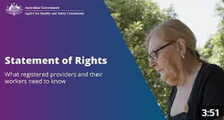  Statement of Rights – introduction for providers and workers | 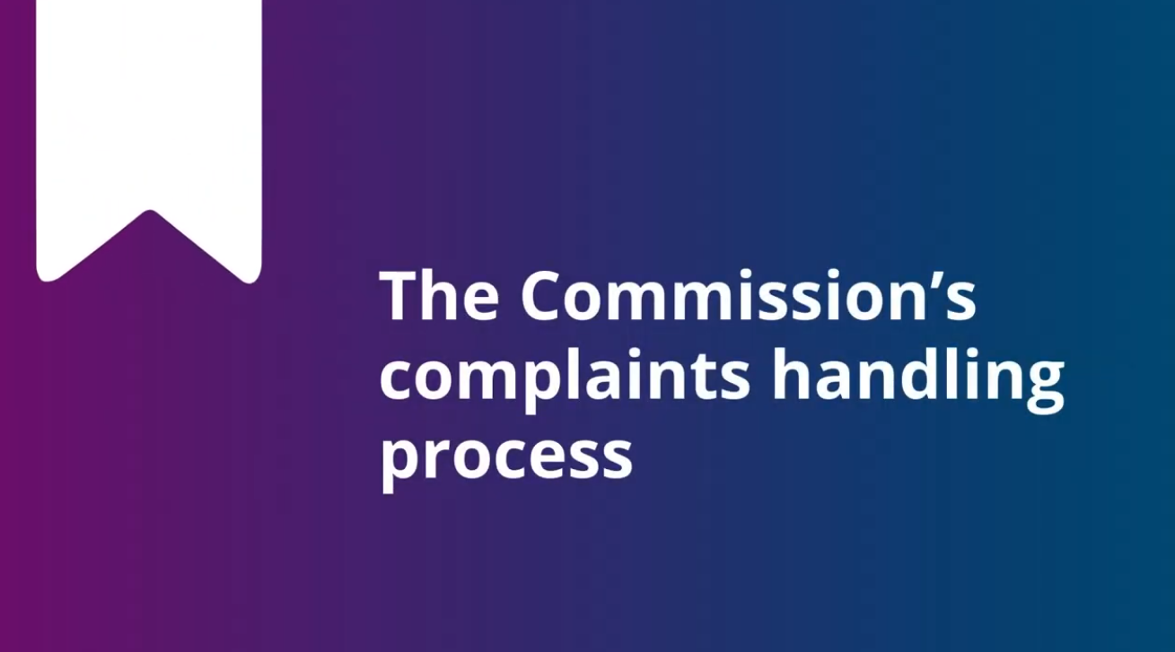  Commission complaints handling process
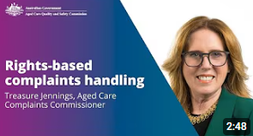  Rights-based complaints handling – an overview by the Aged Care Complaints Commissioner |   First Nations videos

Thank you for your continued commitment to supporting older people to feel safe, respected and heard. If you have any queries or feedback about this program, please reach out to us via communicatons@agedcarequality.gov.au.


