


May 2026
Choice, dignity, respect
– older people’s rights
in aged care
Public Information Program
Provider and Worker Toolkit

About this toolkit
The Aged Care Quality and Safety Commission is the national regulator of Government funded aged care services. It is our role to uphold the rights of older people and protect and enhance their safety, health, wellbeing and quality of life.
Our regulatory functions include listening to the experiences of older people and supporting them to be informed about their aged care rights. We also support and educate providers and workers about those rights and their obligations in meeting them.
We are running a public information program to ensure older people, their families and supporters understand that stronger rights and protections exist under the Aged Care Act 2024.
A video provides an overview of the program.
We know that older people and supporters are more likely to raise concerns with their provider when they feel reassured that:
- it is safe to speak up and they know who they can speak to
- they will be listened to and taken seriously
- raising a concern will not negatively affect their care.
Our public information program is about reaffirming to older people and their supporters that they can feel safe to raise concerns and give feedback directly with their provider, and to trust they will be listened to with respect.

This toolkit provides aged care providers and workers with information and resources to support your engagement with older people, their families and supporters on key topics including:
- the rights of older people in aged care
- raising concerns when something doesn’t feel right
- the role of the provider in supporting older people to speak up
- the role of the Commission and Aged Care Complaints Commissioner.
We have also created materials to help communicate this information through your channels, including newsletter copy, social media posts and links to videos and resources.

What’s in this toolkit?
- Key messages
- Webpages
- Conversation guide
- Social media copy and tiles
- Editorial copy
- Resources for:
  - For providers and workers
  - For older people and their supporters
- Videos

Call to action
When sharing materials we recommend the below calls to action:
- talk to the older people in your care about the Statement of Rights and what their rights mean in practice
- encourage them to watch the video explaining the Statement of Rights – introduction for older people or Rights-based complaints handling – an overview by the Aged Care Complaints Commissioner
- remind them of their right to speak up if they have a concern and ensure they understand your complaints process
- explain that support is available via the Older Persons Advocacy Network and the Aged Care Quality and Safety Commission.

Diverse audiences
We recognise that older people from diverse cultural, linguistic and life backgrounds may have unique needs and preferences. Their background and experience impacts on how they access and engage with aged care supports. This includes differences in language, traditions, identity and family structures.

We are committed to making sure our information is inclusive, culturally safe and responsive. Every older person should feel safe, understood, respected and able to make choices that reflect who they are. If someone you care for has difficulty speaking or understanding English, you can use an interpreting service to communicate in their preferred language.
If you would like any of our resources that are not currently translated, please contact us at communications@agedcarequality.gov.au.

We have developed dedicated information and resources to help you to provide good, culturally safe aged care for First Nations older people. You’ll find these on the First Nations Hub on
our website.

Translating and interpreting services
If you need an interpreter when contacting the Commission, you can ask us to arrange one when you call. Or you can contact one of these services and ask them to help you contact the Commission:
- Translating and Interpreting Service (TIS) – 131 450
- Aboriginal Interpreter Service (AIS) – 1800 334 944
- Aboriginal Interpreting Western Australia – 08 9192 3981
You can download the Translated information for people receiving aged care poster. It has information in different languages about how to contact the Commission using an interpreter.
If you have a hearing or speech impairment, you can contact the Commission through the National Relay Service:
- TTY users: call 1800 555 677 then ask for the Commission’s number 1800 951 822
- Speak and Listen users: call 1800 555 727 then ask for the Commission’s number 1800 951 822
- Internet relay users: connect to the National Relay Service and enter 1800 951 822.

Sign language interpreting and captioning services
The National Sign Language Program (NSLP) provides free sign language interpreting and captioning services through Deaf Connect for eligible older people.
The NSLP can help you with:
- using aged care services and taking part in professional and social activities
- health and medical appointments that are covered by Medicare.
To make a booking, call 1300 773 803, email interpreting@deafconnect.org.au or go to the Deaf Connect website.

Orderable resources and translated materials
The materials in this information kit are available in digital and hard copy format. You can find all the resources listed in this provider information kit on our website.
If you require hard copies of any of these resources, or if you’re looking for translated materials, you can order them via our orderable resources page.

Key messages
You can use the below key messages when engaging with older people, their families and supporters about rights and raising concerns.
- Older people now have stronger rights and protections following recent changes to aged care laws in Australia.
- These changes include a Statement of Rights for older people receiving aged care services. They include the right to make their own decisions, to be respected and to feel safe.
- Older people also have the right to communicate their needs and preferences, to have their culture and identity respected, and to stay connected with their community.
- If an older person has a concern about their aged care services, they have the right to speak up.
- They can talk to their provider first. Their provider must respect their rights and have a complaints process that is easy to understand and use.
- They can choose to have a family member or supporter raise a concern on their behalf.
- If older people need help making a complaint or finding information, they can contact the Older Persons Advocacy Network (OPAN) for free, independent, and confidential support. ​Call the Aged Care Advocacy Line on 1800 700 600.
- If an older person prefers, they can contact the Aged Care Quality and Safety Commission directly to make a complaint or give feedback.
- The new Aged Care Complaints Commissioner works within the Commission to make sure every concern is handled in a way that is confidential, timely and fair.

Webpages
The webpages listed below provide key information for both providers and older people receiving aged care services.
Choice, dignity, respect – your rights in aged care
Find out more about older people’s rights in aged care, provider obligations in supporting older people to raise their concerns, and the role of the Aged Care Quality and Safety Commission.
How to raise a concern – for older people
Find out more about what to do if you have a concern, rights and protections under the new Aged Care Act 2024, and how the Aged Care Quality and Safety Commission can help.
Good complaints practice – for providers
An overview of good complaints practice for providers including links to guides, fact sheets and our complaints handling checklist.
Make a complaint
Access the Aged Care Quality and Safety Commission’s online complaints form or find out more about making a complaint by phone or in writing.
Aged care complaints FAQs
Detailed answers to a range of questions about complaints, covering:
- how the Commission can help​
- what to know before, during and after making a complaint​
- information for providers and workers​
- useful services.
First Nations Hub
Information and resources to help you to provide good, culturally safe aged care for First Nations older people.

Conversation guide
This conversation guide can be used to talk with older people, their families and supporters about their rights under the Aged Care Act 2024, how to raise concerns or complaints, and support available.
If you are speaking with First Nations older people about their aged care, please refer to our First Nations – Conversation Guide – Yarning about aged care .
How has aged care changed under the new Act?
Older people now have stronger rights and protections following recent changes to aged care laws in Australia. The new Aged Care Act 2024, which started from 1 November 2025, focuses on empowering older people and upholding their rights, needs and personal choices.
The new Act places older people at the centre of their aged care experience – in their home, community settings or in a residential aged care home. It makes sure you have explicit rights, and ways to protect those rights.
These changes include a Statement of Rights which outlines your rights when accessing or seeking to access aged care services. They include the right to make your own decisions, to be respected, and to feel safe.
What is the Statement of Rights?
The Statement of Rights is part of the new Aged Care Act 2024. They say that you have the right to:
- make decisions about your own life
- have your decisions not just accepted, but respected
- get information and support to help you make your own decisions
- communicate your wishes, needs and preferences
- feel safe and respected
- have your culture and identity respected
- stay connected with your community.
If you believe that a provider isn’t acting in a way that’s in line with the Statement of Rights, they can make a complaint to the Aged Care Complaints Commissioner.
What does the Statement of Rights mean in practical terms for my care experience?
You can expect that you are treated with dignity and respect. Some ways in which your rights can look in practice could include that your provider will:
- support you to make informed decisions about your care, including how you access aged care services and who provides them
- support your preferences for your daily routine
- seek, listen and respond to your feedback and concerns
- make sure you can access the things you need
- make sure you are only taking the medicines you need and have been prescribed to you
- provide food and drink options that you like
- keep you connected with the people who are important to you
What obligations does my provider have? What should I expect from them?
Aged care providers must respect the older people in their care and provide services that are quality, safe and meet their needs. This includes delivering care and services that meet:
- the Strengthened Aged Care Quality Standards - a set of requirements that providers need to meet to make sure older people receive safe and quality care
- the Statement of Rights - details the rights that older people have when receiving aged care
- the Aged Care Code of Conduct (Code) - describes how aged care providers, responsible persons and workers (including volunteers) must behave and treat people receiving aged care.
If an older person believes that a provider isn’t acting in a way that’s in line with the above obligations, they can make a complaint to the Aged Care Complaints Commissioner.
The Aged Care Quality and Safety Commission has a range of resources of their website explaining what these obligations mean for older people.
Is it safe to raise a concern or complaint about my provider?
It’s safe to speak up, and it can improve the quality of care for everyone. A provider, worker or responsible person can’t punish you or treat you differently for raising a concern.
The Aged Care Quality and Safety Commission want everyone to feel safe to make a complaint or provide feedback in whatever way suits them. You can talk with the Commission if you’re worried about the consequences of raising a concern. They can talk with you about:
- your options for making a complaint or giving feedback
- how the Aged Care Act 2024 protects you.
How do I raise a concern or complaint? Where do I start?
Often, the best and quickest way to resolve concerns is to raise them directly with the provider, if you feel comfortable doing that.
It’s safe to speak up. A provider, worker or responsible person can’t punish you or treat you differently for making a complaint.
Before speaking to your provider:
- try writing down your concerns
- remember to focus on the facts
- include important information, such as names, dates and locations
- be clear about what you want to happen from the complaint
- ask for help. If you’re concerned, you can ask a friend, family member or supporter to help you write your complaint.
You can also arrange for an advocate to support you if you don’t feel comfortable raising a concern on your own.
If you don’t want to discuss your concern with the provider, or the provider hasn’t been able to resolve your complaint, you can contact the Aged Care Quality and Safety Commission on 1800 951 822. They can talk with you about your options for making a complaint or giving feedback, and how the Aged Care Act 2024 protects you.
Can a family member, supporter or friend help me?
Anyone can make a complaint or support you in making one, including:
- people receiving aged care
- family, friends, carers and supporters of people who receive aged care
- aged care workers and volunteers
- health and medical professionals.
If you're making a complaint for someone else, let them know. They have a right to be involved.
What does the Aged Care Quality and Safety Commission do?
The Aged Care Quality and Safety Commission (the Commission) is the national regulator of Australian Government-funded aged care services. They work with providers, workers and older people to protect the wellbeing and rights of people receiving aged care.
They’re responsible for:
- safeguarding and upholding the rights of older people under the Statement of Rights
- registering providers to deliver aged care
- working with and educating the aged care sector and older people about what the Commission does
- resolving complaints about aged care providers, workers and responsible persons
- auditing providers against the strengthened Aged Care Quality Standards
- monitoring and investigating registered providers, aged care workers and responsible persons
- responding to notifications of reportable incidents
- regulating aged care workers, volunteers, responsible persons and providers under the Aged Care Code of Conduct.
What is the role of the Aged Care Complaints Commissioner?
The Aged Care Complaints Commissioner is appointed by the Minister for Aged Care and Seniors and has an important role in aged care.
They give older people a voice so they can raise concerns about their care, without fear of consequences or retaliation. It’s their responsibility to make sure complaints and feedback are handled in a way that is transparent and accountable.
To do this, they work alongside the Aged Care Quality and Safety Commission.

What does the Older Persons Advocacy Network (OPAN) do?
OPAN provides free, independent and confidential support to older people seeking or receiving government funded aged care services.
If you require information or support with government-funded aged care services, OPAN’s Aged Care Advocacy Line can provide free, confidential, and independent support. You can speak with an advocate by calling 1800 700 600 or visit the OPAN website.
What types of complaints can the Aged Care Quality and Safety Commission help with?
The Commission can help with complaints about a providers’ responsibilities under the Aged Care Act 2024 or their funding agreement with the Australian Government.
They can help you with complaints about:
- a provider, worker or responsible person not meeting their obligations under the Aged Care Act 2024
- a provider not acting in line with the Statement of Rights. For example, not respecting older peoples’ right to:
- be treated with dignity and respect
- make a complaint
- receive care that is safe, high quality, meets their needs and helps them to live their best life
- personal care, such as services that help someone to shower, take medication, eat or move around
- communication, for example how a provider, worker or responsible person shares information with you and responds to your questions or complaints
- staff roles, for example how workers do their job and care for you
- your living environment, for example safety, security and cleaning
- some fees and charges .
It doesn’t cost anything to ask the Commission for help or to make a complaint.
How do I contact the Commission to leave feedback or to make a complaint?
You contact the Commission:
- by calling 1800 951 822 (free call)
- online via www.agedcarequality.gov.au/contact-us/complaints-feedback/make-complaint
- by writing to Aged Care Quality and Safety Commission
GPO Box 9819, in your capital city.
What will happen when I contact the Aged Care Quality and Safety Commission?
When you contact the Commission, they will:
- listen to you and explain your rights
- find out what you’d like your provider to do differently
- explain their role and how they can best help you.
Can I remain anonymous if I make a complaint to the Aged Care Quality and Safety Commission?
Yes, you can choose to remain anonymous.
When you call the Commission to share a concern you decide on how they proceed, and your privacy is protected at all times.
- you can leave feedback without being involved in how they handle it
- you can make a complaint and be part of the resolution process
- you can ask for your concern to be confidential
- you can remain anonymous.
If you make an anonymous complaint:
- the Commission won't know your identity
- they will take reasonable steps not to share information that could reveal your identity to the provider, worker or responsible person when they discuss your complaint with them. They do the same for anyone else you mention in your complaint, if you ask them to.
This also means that:
- they can’t keep you informed about how your complaint’s going
- you can’t give them more information
- they might treat it as feedback if they can’t follow the complaints process because they can’t contact you
- they can’t tell you the outcome of your complaint or explain your reconsideration rights.
Will my provider know it’s me that raised the concern or complaint with the Commission?
You can make a complaint confidentially with the Commission. If you make a confidential complaint, the Commission will:
- know your identity
- take reasonable steps not to disclose (reveal) your identity to the provider, worker or responsible person when they discuss your complaint with them. They do the same for anyone else you mention in your complaint, if you ask them to
- keep you informed about how your complaint’s going
- involve you in the resolution process as much as possible without revealing your identity.
I don’t want to make a complaint, but I have a concern about aged care. Can the Aged Care Quality and Safety Commission help?
Yes, you can call the Commission on 1800 951 822 and they can discuss your situation. Their friendly staff will listen to your needs and tell you your options so you can decide what works best for you.
If you’re concerned about the care you (or someone else) are receiving from an aged care provider, worker or responsible person, but you don’t want to make a complaint, you can raise your concern with them as feedback.
Giving feedback is less formal than making a complaint. They usually won’t involve you in the process of addressing your feedback. You can find out more at Give feedback.

Social media copy and tiles
We’ve developed the below social media tiles and copy to raise awareness about sharing feedback or making a complaint. Share these with your networks on your social media channels. We encourage you to include information about your complaints process to help older people, their families and supporters understand how to raise a concern or make complaint.
Channel | Copy | Visual Asset
LinkedIn  Facebook | Older people have the right to make their own decisions, to be respected and to feel safe. The Aged Care Quality and Safety Commission is raising awareness about older people’s rights in aged care.  Everyone has the right to choice, dignity and respect and to feel safe, heard and supported.  Learn more at agedcarequality.gov.au or call 1800 951 822.  #ACQSC #Complaints #AgedCareQuality #AgedCareRights | Embed video: Rights-based and person-centred care – what it means for older people
LinkedIn  Facebook | Everyone has the right to choice, dignity and respect in aged care. The Aged Care Quality and Safety Commission is encouraging older people to speak up if something isn’t right in aged care.  If you have a concern, you can talk to your provider first.  You can also contact the Aged Care Quality and Safety Commission for independent information, feedback or complaints.  Visit agedcarequality.gov.au or call 1800 951 822.  #ACQSC #Complaints #AgedCareQuality #AgedCareRights | Embed image: www.agedcarequality.gov.au/media/102380  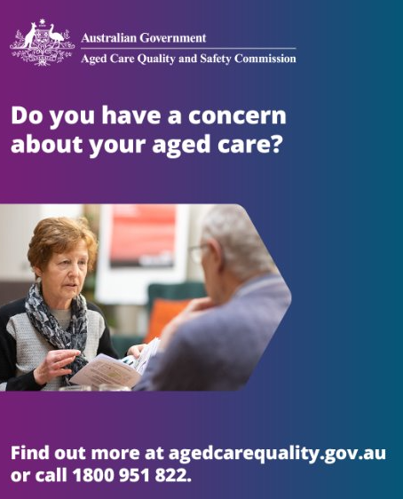
LinkedIn | Culturally safe care is your right. The Aged Care Quality and Safety Commission has created new resources to support First Nations providers, workers and older people understand their rights and obligations in ensuring First Nations older people get the good quality, culturally appropriate and safe aged care everyone is entitled to.  This video discusses the importance of cultural training for aged care workers to deliver good quality, culturally appropriate and safe aged care for Australian First Nations older people.  Choice, dignity, respect – your rights in aged care.  Find out more at agedcarequality.gov.au or call 1800 951 822.  #ACQSC #Complaints #AgedCareQuality #AgedCareRights | Embed video: Culturally safe care is your right
Facebook | Good aged care means you are safe and cared for in the right way. It means respecting your connection to family, your community and your Country.  New aged care laws include the Statement of Rights to help make sure everyone is getting good and safe aged care.  You can find more resources to support older First Nations people, their families and aged care workers and providers who care for them at agedcarequality.gov.au/FirstNations | Embed video: Your rights in aged care

Editorial copy
Use this article on your website, in an email or in your newsletter to promote the rights of older people receiving aged care and how they can raise a concern or make a complaint. We encourage you to add specific information about the complaints process in your organisation.
Choice, dignity, respect – your rights in aged care
Older people now have stronger rights and protections following recent changes to aged care laws in Australia.
These changes include a Statement of Rights for older people receiving aged care services. They include the right to make your own decisions, to be respected and to feel safe.
As your aged care provider, it is our responsibility to ensure that these rights are upheld, and that you are placed at the centre of your aged care experience.
We encourage you to talk to us if you have any concerns or questions about your care or services. It is an obligation for us to provide a complaints process that is easy to understand and access.
We’re committed to providing you with safe, quality care that meets your needs and preferences. Raising your concerns with us is often the most effective way to resolve things. It is safe to speak up.
If you would like to provide feedback, raise a concern or complaint [insert specific information about your complaints process]
You can also choose to have a family member or supporter raise a concern on your behalf. If you need help making a complaint or finding information, contact the Older Persons Advocacy Network (OPAN) for free, independent, and confidential support. ​Call the Aged Care Advocacy Line on 1800 700 600.
The Aged Care Quality and Safety Commission is the national regulator of government funded aged care services. You can contact the Commission if you’d like independent advice or support in raising a concern. To contact the Commission:
- Call 1800 951 822 between 9am – 5pm Monday to Friday
- Write to Aged Care Quality and Safety Commission, GPO Box 9819, in your capital city
- Email info@agedcarequality.gov.au ​

Resources
The Commission has a range of information and resources available about raising concerns or making a complaint. You can find out more at www.agedcarequality.gov.au.
We recommend the below resources to build your knowledge about best practice complaints handling and to improve your processes where required. We also have a selection of resources specifically for First Nations older people.

For providers and workers
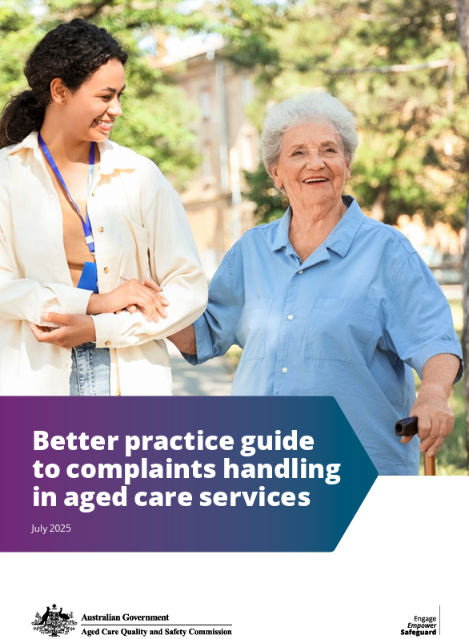  Better practice guide to complaints handling in aged care services | 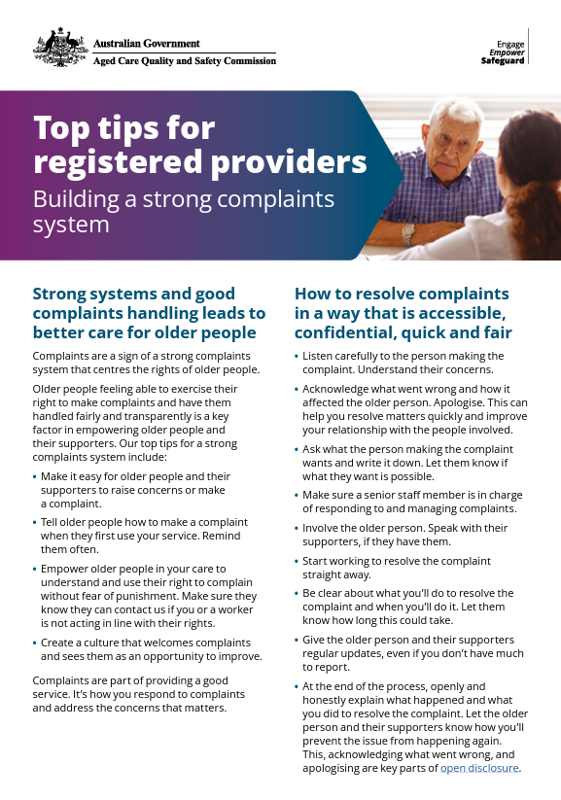  Top tips for registered providers: Building a strong complaints system | 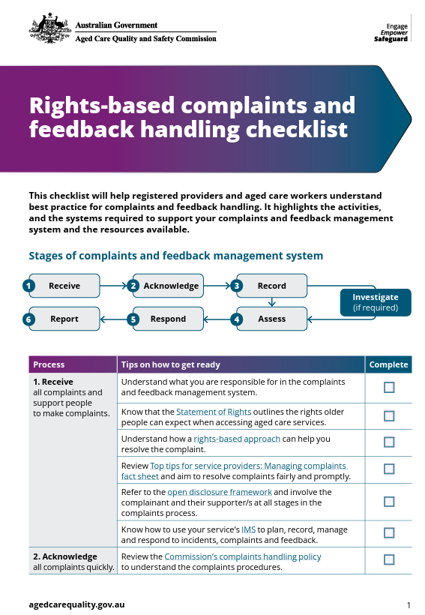  Complaints handling checklist
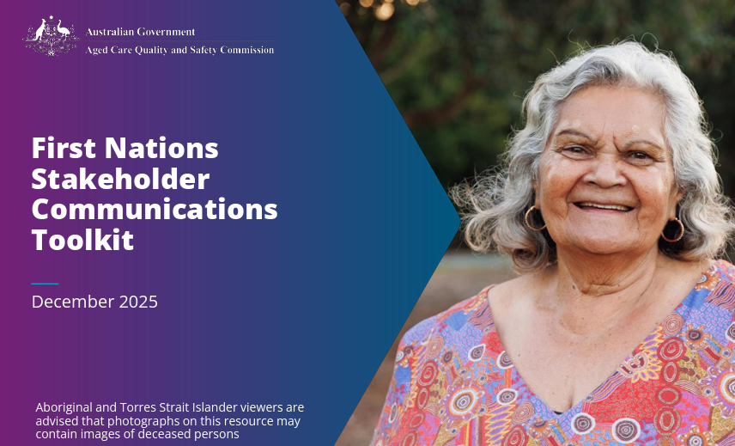  First Nations - Stakeholder Communications Toolkit | 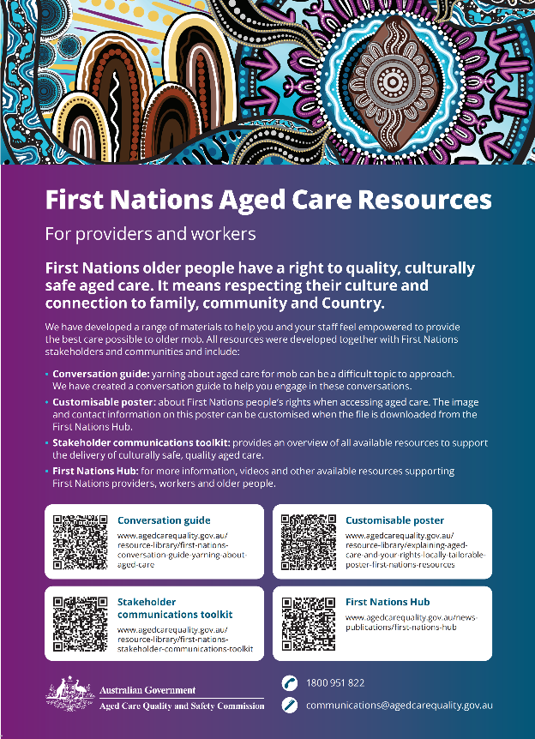  First Nations Aged Care Resources | 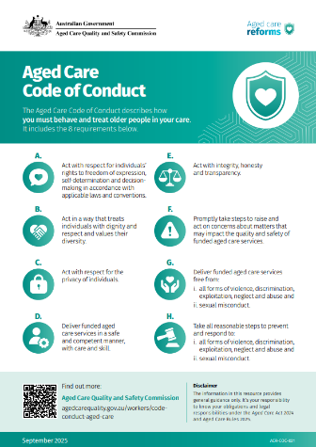  Aged Care Code of Conduct – responsible persons and aged care worker poster

For older people and their families
Use these resources by:
- linking to them on your website, in newsletters and social media
- making hard copies available in your services.
You can order hard copies of the resources for older people (including translated versions) via our Order resources webpage.
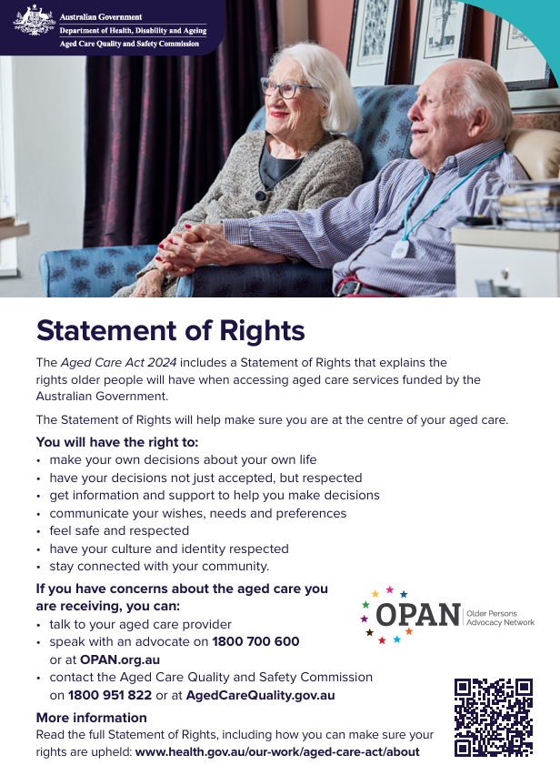  Fact sheet – Your rights in aged care | Poster – Your rights in aged care | 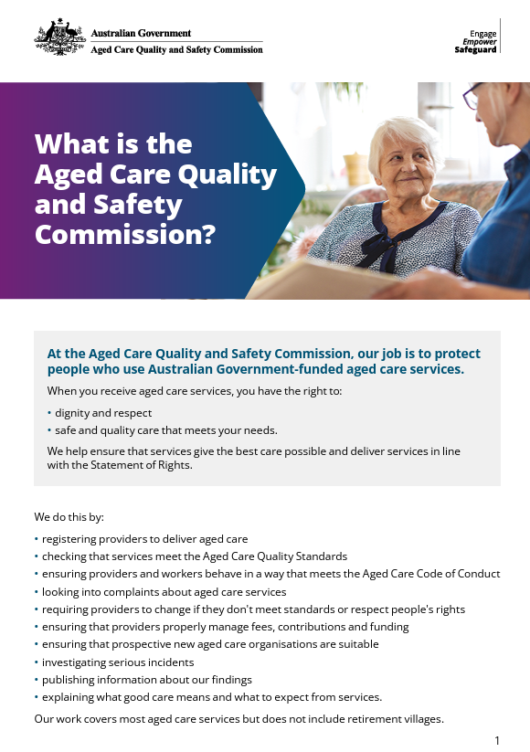  Fact sheet – What is the Aged Care Quality and Safety Commission
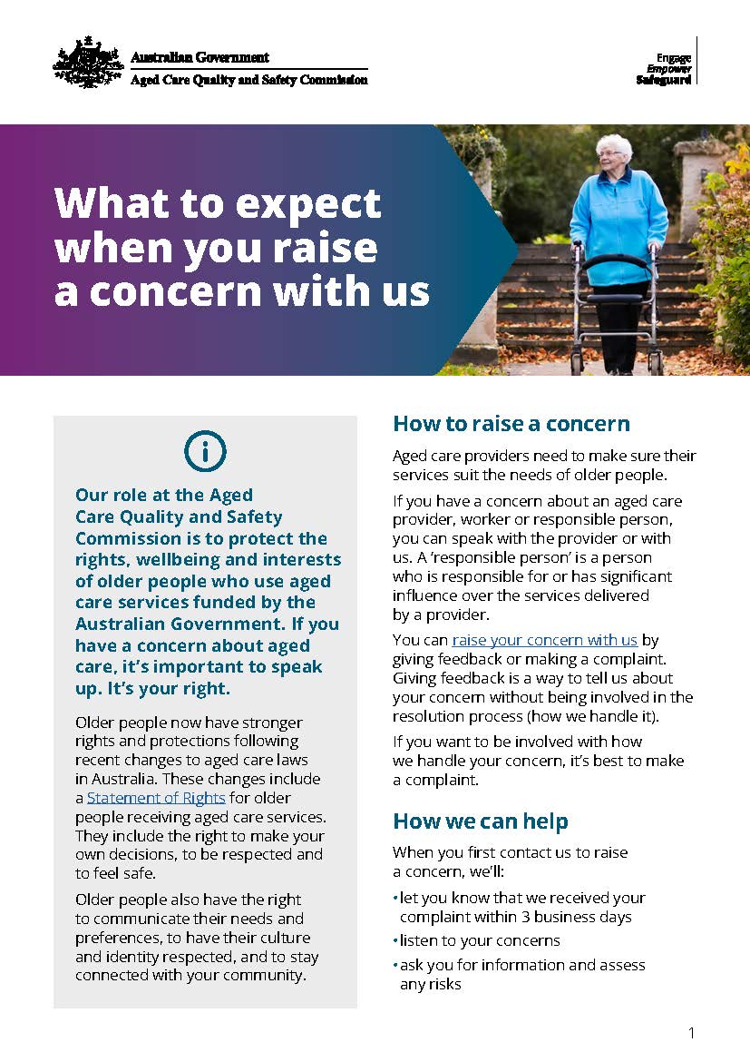Fact sheet – What to expect when you raise a concern with us | 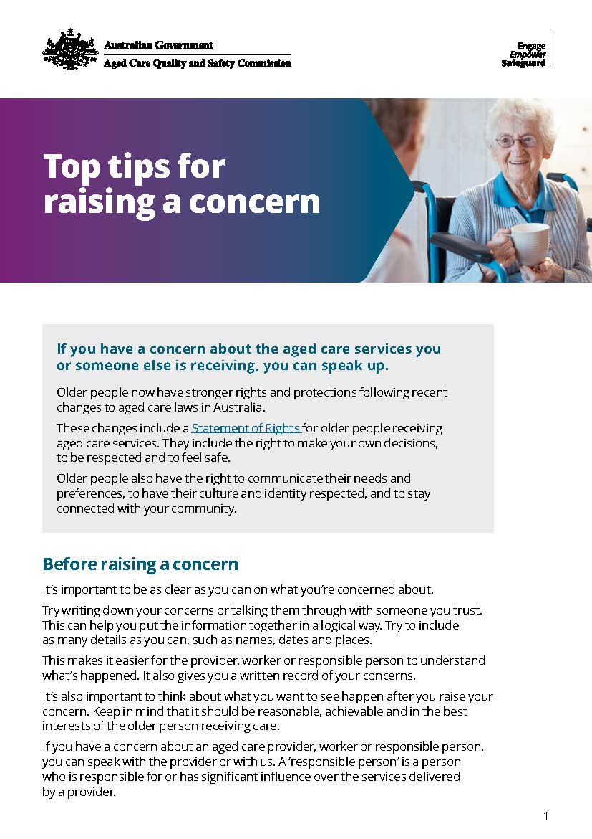  Fact sheet – Top tips for raising a concern | 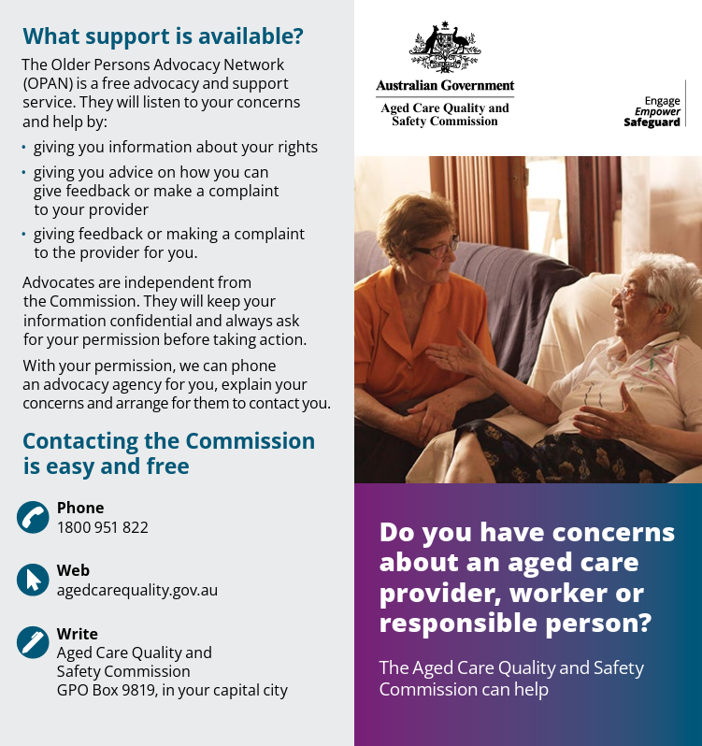  Brochure – Do you have concerns about an aged care provider, worker or responsible person
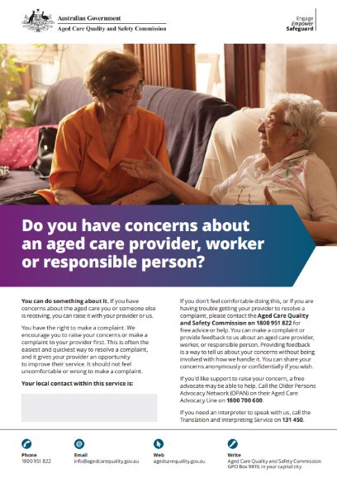  Poster – Do you have concerns about an aged care provider, worker or responsible person | 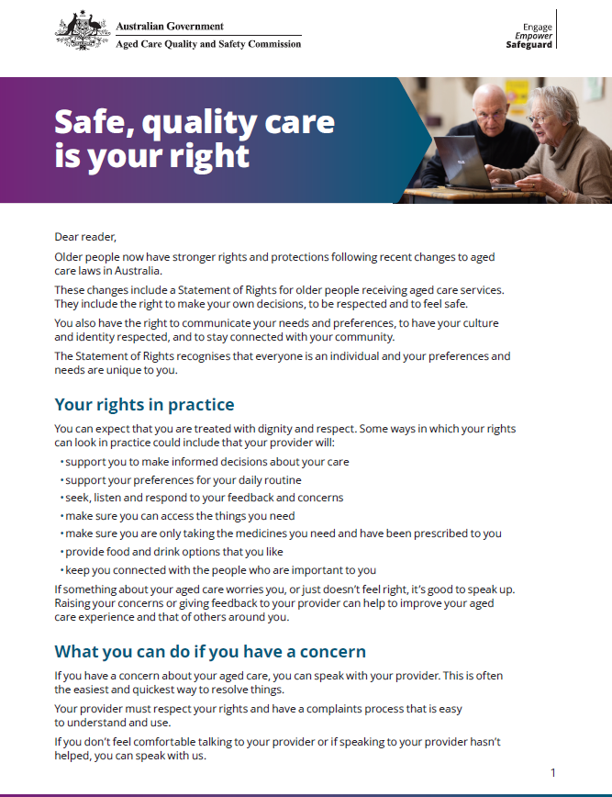  Letter from the ACQSC Commissioner and Aged Care Complaints Commissioner – Safe, quality care is your right | 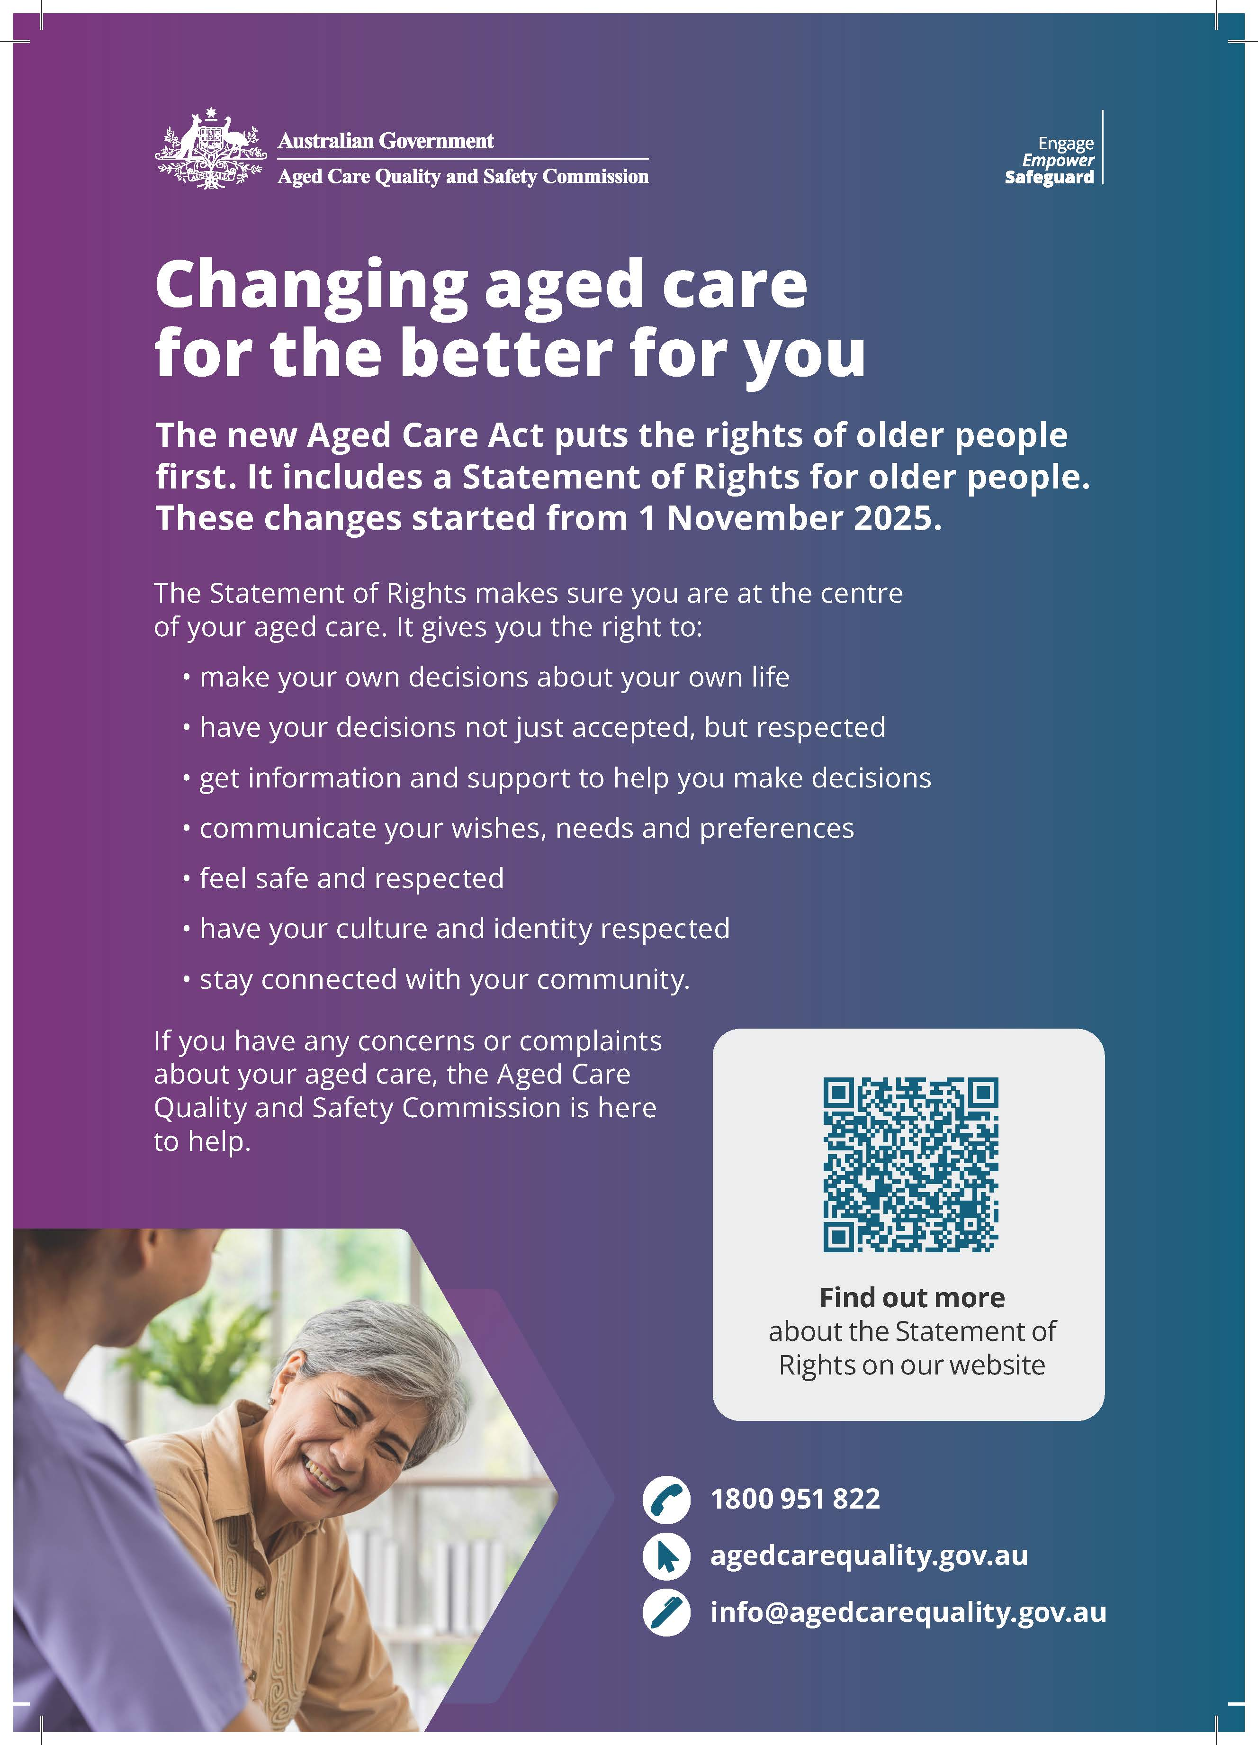  Poster – Diverse audiences: Changing aged care for the better
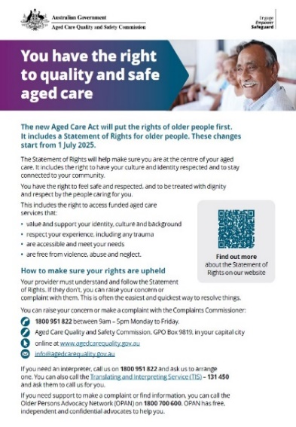  Fact sheet – Diverse audiences: You have the right to quality and safe aged care | 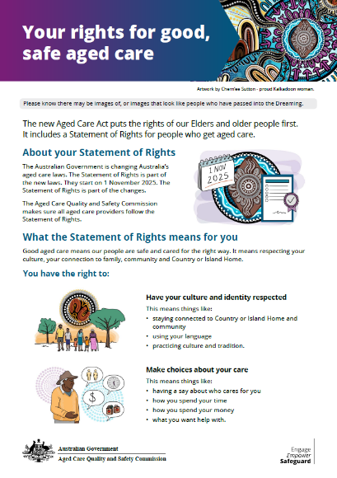  First Nations Statement of Rights Information Sheet | 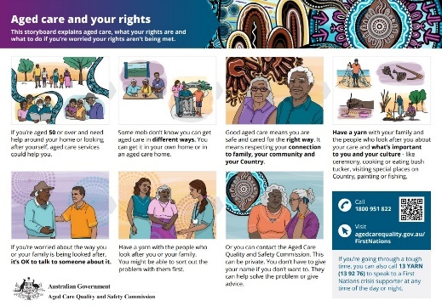  First Nations – Visual Storyboard – Aged care and your rights

You can order hard copies of the resources for older people (including translated versions) via our Order resources webpage.

Videos
Use these videos to build staff knowledge, display in common areas at your aged care service or to post on your website/social media.
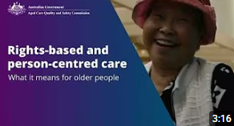  Rights-based and person-centred care – what it means for older people | 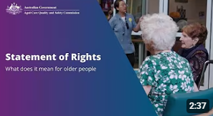  Statement of Rights – introduction for older people
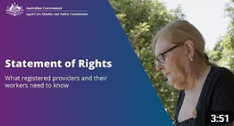  Statement of Rights – introduction for providers and workers | 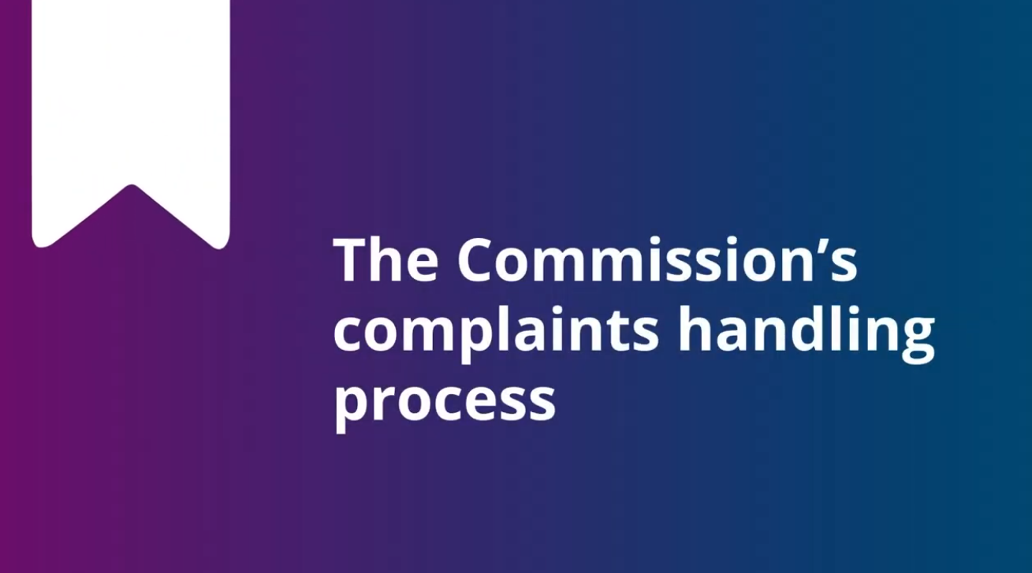  Commission complaints handling process
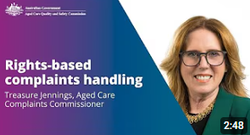  Rights-based complaints handling – an overview by the Aged Care Complaints Commissioner | 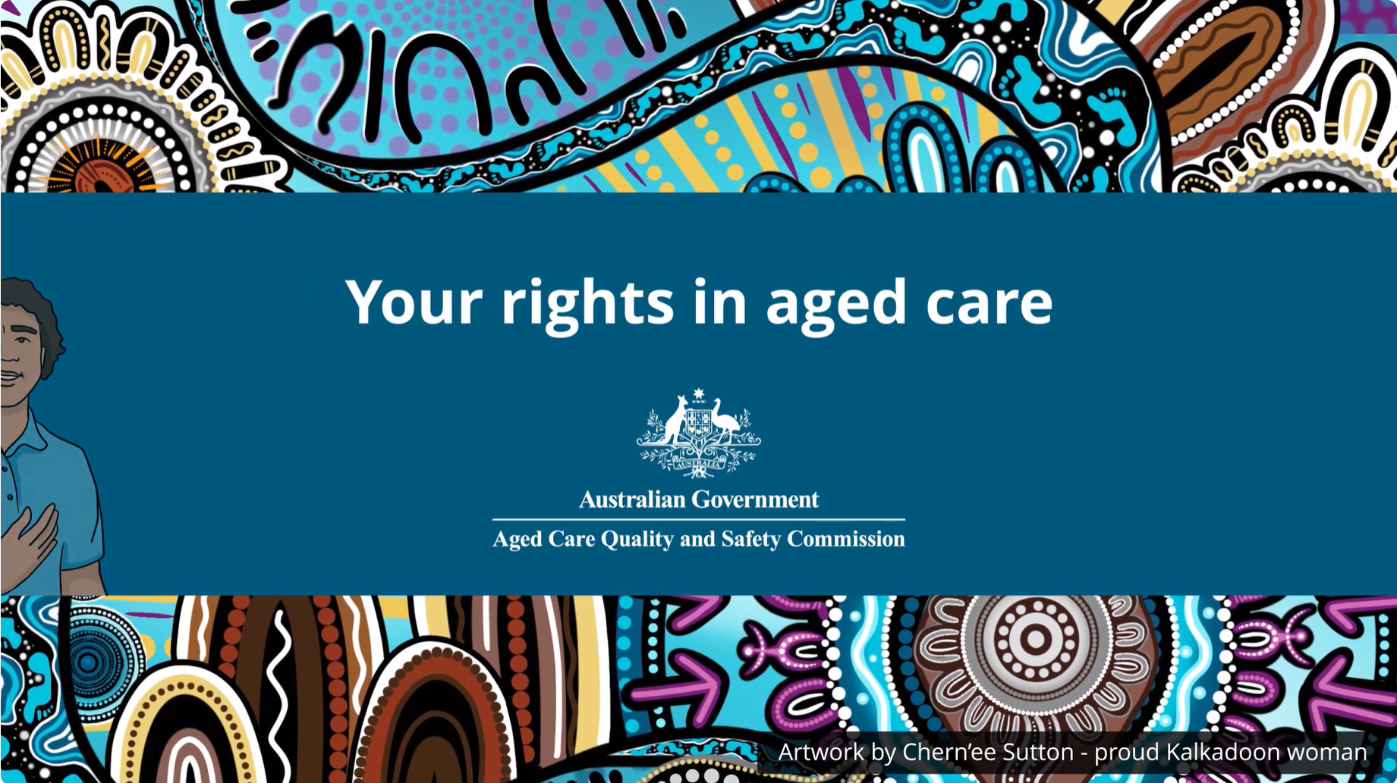  First Nations – Your rights in aged care

Thank you for your continued commitment to supporting older people to feel safe, respected and heard. If you have any queries or feedback about this program, please reach out to us via communications@agedcarequality.gov.au.


