
Regulatory Bulletin
TITLE | Responding to non-compliance with the Aged Care Quality Standards
Bulletin number | RB 2019-04
Version number | 2.0
Document number | FRM-ACC-0604
Publication date | 24 February 2020
Replaces | 2019-4.1 published 2 January 2020
Information in this bulletin applies to | - All residential aged care services and flexible care services through which short-term restorative care is provided in a residential care setting  - All home care services, Commonwealth Home Support Programme (CHSP) services and flexible care services through which short-term restorative care is provided in a home care setting.
Attachment | n/a
Notes | This Regulatory Bulletin has been updated to include a new table of information on page 1 as well as minor formatting changes.
To be reviewed | 24 February 2021

Regulatory Bulletin

RB 2019-04: Responding to non-compliance with the Aged Care Quality Standards
The Aged Care Quality and Safety Commission (Commission) seeks to protect and enhance the safety, health, well-being and quality of life of aged care consumers; and promote consumers’ confidence and trust in the quality and safety of Australian Government funded aged care services.
When an Assessment Team identifies evidence during a performance assessment that the care and services provided in a service do not meet the Quality Standards, the Commission will consider whether the provider complies with the Quality Standards.
The Commission’s response to non-compliance will be risk-based and proportionate to ensure the service returns to compliance and addresses any risks to the safety, health and wellbeing of consumers.
This Regulatory Bulletin outlines how the Commission will respond to and manage non-compliance with the Aged Care Quality Standards from 1 January 2020.
In this Bulletin:
- Aged care provider(s) or providers means both approved providers of residential aged care services and home service providers.
- Quality Standards refers to the Aged Care Quality Standards.
- Commissioner includes the Commissioner or a delegate of the Commissioner.
- The Commission Rules refers to the Aged Care Quality and Safety Commission Rules 2018.
- Performance assessment includes:
  - accreditation of commencing services (Part 3, Division 3, Subdivision C)
  - re-accreditation of recommencing services (Part 3, Division 3, Subdivision C)
  - re-accreditation of residential services other than recommencing services (Part 3, Division 3, Subdivision D)
  - quality audit of home services (Part 4, Division 3)
  - assessment contacts for the purpose of assessing the provider’s performance, in relation to the service, against the Quality Standards (Part 5, Division 5,
Subdivision C)
  - review audits of accredited services (Part 5, Division 6).
Key points
- When there is evidence that the care and services provided in a service do not meet the Aged Care Quality Standards (Quality Standards), the Commission will consider whether the provider complies with the Quality Standards.
- The Commission’s response to non-compliance is proportionate to the level of assessed risk and the potential consequences of that risk for consumers.
- The Commission has a consistent approach to assessing risk across all providers. A risk assessment considers harm to consumers and trust of providers to inform the way the Commission organises and conducts assessments and determines the regulatory approach to non-compliance.
- The Commission may take administrative actions or enforceable regulatory actions in managing non-compliance.
- The Commission determines the form and frequency of performance assessment or monitoring contact with the provider in developing a risk-based monitoring plan.

Aged Care Quality and Safety Commission Rules 2018
Under the Aged Care Quality and Safety Commission Act 2018, the Aged Care Quality and Safety Commissioner (Commissioner) has responsibility for assessing the performance of aged care providers against the Quality Standards. The Commission Rules detail the procedure to be followed by the Commissioner in assessing performance.

The following requirements in the Commission Rules are similar for each type of performance assessment:
- the Assessment Team must assess the quality of care and services provided through the service against the Quality Standards
- the Commissioner develops a performance report that includes an assessment of the provider’s performance, in relation to the service, against the Quality Standards
- the performance report may specify any areas in which improvements in relation to the service must be made to ensure the Quality Standards are complied with.
Where there is non-compliance with the Quality Standards, the Commissioner is empowered to issue the provider of the service with a:
  - Direction to revise a Plan for Continuous Improvement
  - Non-Compliance Notice
  - Notice to Remedy
  - Notice of Decision to Impose Sanctions.

Frequently asked questions
- How does the Commission identify non-compliance with the Aged Care Quality Standards?
Assessment Teams consisting of registered quality assessors undertake performance assessments through site audits, review audits, quality audits and assessment contacts under the Commission Rules. A performance assessment consists of obtaining and evaluating evidence to demonstrate performance against the Quality Standards. Assessment Teams conduct the performance assessment by collecting evidence of the quality of care and services at a service including through observations, interviews and document review.
Assessment Teams prepare a written report which details a summary of their findings at the Standard level; assessment of met or not met against each assessed requirement of the Quality Standards; and detailed findings and evidence from the assessment.
The Assessment Team will also identify in the report any concerns about potential risk of harm to the safety, health and well-being of consumers.
The Commission then provides the assessment report to the provider of the service so that they have the opportunity to:
- understand the reasons, evidence and facts that the decision-maker is to rely on in identifying areas for improvement and making a decision regarding compliance
- provide a response to matters identified in the assessment report that may be relied on by the decision maker.
Following each performance assessment, a delegate of the Commissioner considers the Assessment Teams report, the provider’s response and other relevant information; and develops a performance report.
The performance report details the delegate’s assessment of the provider’s performance, in relation to the service, against the Quality Standards. The Quality Standard and requirements are assessed as either compliant or non-compliant at the Standard and requirement level where applicable.
The report may also specify areas in which improvements must be made to ensure the Quality Standards are complied with.

- How will the Commission respond to non-compliance with the Quality Standards?
When the Commission determines that a provider of a service is non-compliant with the Quality Standards, the Commission will make a finding of non-compliance and notify the service.
The Commission’s response to non-compliance is proportionate to the level of assessed risk (Diagram 1, below).
Diagram 1, Risk-based management of non-compliance
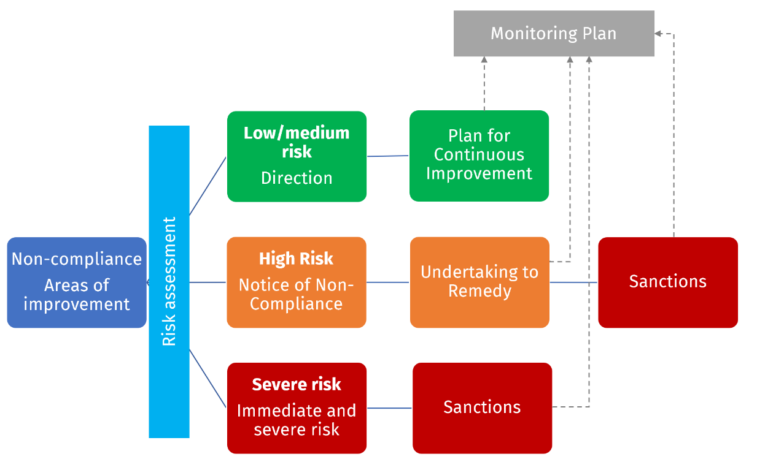
Low or medium risk: Administrative action
Administrative action may apply where risk is assessed as low or medium. Administrative engagement allows the Commission to bring the non-compliance to a provider’s attention and encourages the provider to rectify the non-compliance.
The Commission will issue to the provider a Direction to revise the Plan for Continuous Improvement (PCI) for the service. The revised plan must be given to the Commission.
If the Commission is not satisfied that necessary improvements are being made to meet the Quality Standards as outlined in the plan for continuous improvement, then the Commission may escalate regulatory action.

High or severe risk: Enforceable regulatory action
The Commission may apply enforceable regulatory action where risk is assessed as high or severe.
Regulatory action allows the Commission to actively encourage the provider to return to compliance with its responsibilities as quickly as possible and/or to deter the provider from future non-compliance.
A Non-Compliance Notice is issued to the provider if the Commission is satisfied that a provider is non-compliant with its responsibilities under the Aged Care Act 1997.
The Non-Compliance Notice advises the provider of the non-compliance and gives the provider the opportunity to respond. If the Delegate is satisfied with the provider’s response to a Non-Compliance Notice, a Notice to Remedy may be issued which requires the provider to remedy the non-compliance within a certain period. In response to the Notice to Remedy, the provider gives the Commission an Undertaking to Remedy committing to take the required actions within the specified timeframes.
If the Delegate is not satisfied with the provider’s response to the Non-Compliance Notice or where there is immediate and severe risk, the Delegate may issue a Notice of Decision to Impose Sanctions. This notifies the provider, in writing, of the Delegate’s decision to impose one or more sanctions on the provider.
A Direction to revise the PCI will not be issued where a risk assessment indicates that enforceable regulatory actions are more appropriate.
- Risk of harm to consumers
Where there is evidence of non-compliance against the Quality Standards, the Commission considers the potential risk to consumers posed by the non-compliance. The Commission may require an Assessment Team to focus their attention on site to obtaining further evidence about the risk to consumer(s) to determine the potential risk of harm to consumers.
The Assessment Team will raise concerns regarding possible non-compliance and risk to consumers with the person in charge of the service to alert them to the evidence identified by the Assessment Team. This will enable the service to address risks at the point of care and to take early action to ensure the safety, health and well-being of consumers.
In cases where it has been determined that a provider’s non-compliance poses an immediate and severe risk to consumers the Commission will respond by issuing a sanction.

- What is the Commission’s approach to monitoring non-compliance?
Risk-based monitoring and management of the non-compliance is determined by the Commission based on the nature of non-compliance; the level of risk to consumers; what is known about the provider; and the information in the providers revised PCI or Undertaking to Remedy.
The Commission determines the form and frequency of performance assessment or monitoring contact with the provider in developing a risk-based monitoring plan. For example, where assessed risk is rated as high or severe, the Commission will conduct more intensive monitoring with case management coordination.
- What happens if the service has not made necessary improvements to comply with the Quality Standards?
If the Commission is not satisfied that necessary improvements are being made to meet the Quality Standards, then the Commission may take further actions such as:
- further assessment contacts to assess performance or monitor quality of care and services; this may be unannounced and conducted at any time
- specified requests for information about an identified risk
- for residential services, consideration of whether there are reasonable grounds to escalate to a review audit, which in turn could result in varying or revoking accreditation of the service
- for home services, consideration of whether there are reasonable grounds to escalate to a quality review
- further monitoring of compliance with the Quality Standards at other services operated by the provider when risks of poor quality of care are evident in a number of that provider’s services
- enforceable regulatory action including Non-Compliance Notice or a Notice of Decision to Impose Sanctions.
- Will a provider have an opportunity to respond to an Assessment Team’s report prior to a decision of non-compliance?
The Commission Rules detail the procedures to be followed by the Commissioner. Procedural fairness will be given to a provider who may be negatively affected by a finding by the Commissioner. Before making a non-compliance decision, Commission delegates will ensure natural justice.

For example, the Commission will provide the assessment report to the provider to allow them to understand the reasons, evidence and facts that the decision-maker is to rely on when making a decision of non-compliance. Giving the assessment report to the provider also affords them an opportunity to provide a response to matters identified in the report in advance of a finding being made by the Commission.
- What compliance information is made public?
A range of information on the performance of services is published on the Commission’s website or the My Aged Care website including:
- performance reports for residential services following a site audit or a review audit
- accreditation decisions for residential services
- Directions to revise a plan for continuous improvement
- information regarding the Notice of Non-Compliance
- information on all sanctions imposed.
Where applicable this information includes non-compliance decisions.
The Commission is committed to making more information from other quality monitoring regulatory activities available and will publish performance reports following quality reviews with home services and performance reports following assessment contacts from 1 July 2020. This information will include reporting on additional functions that the Commission manages from 1 January 2020.
Under the Commission Rules, the Commission may consider making other performance information public including if it is in the public interest to do so.
- What further regulatory action may be taken by the Commission?
The Commission may consider a provider’s suitability to be an approved provider of aged care services where assessed risk is severe.
Revocation of approval of approved provider can be initiated by the Commission either:
- as a result of Sanction or failure to comply with the avoidance provisions of a Sanction
- because the provider has ceased to be suitable for approval.

Need to know more?
If you have any questions or feedback on this Bulletin, please send an email to: info@agedcarequality.gov.au. Stay up to date with Regulatory Bulletin releases by subscribing to the Commission’s newsletter, Quality Standard.

