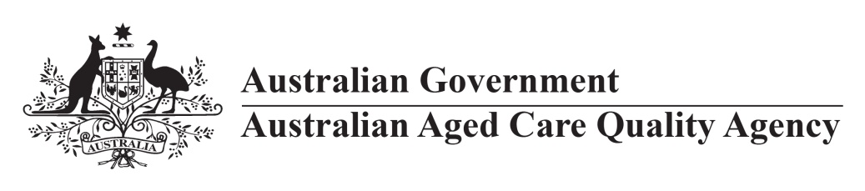
Communique 1
Update on Standards Guidance development

- The Australian Aged Care Quality Agency (the Quality Agency) has commenced the development of Guidance material to support the single set of aged care Standards.
This is a critical opportunity to set clear expectations of what is required to demonstrate that the Standards are being met.

- The primary purpose is to provide guidance for providers about the evidence requirements of the Standards, how they can demonstrate their performance against the Standards, and considerations of how this performance will be measured.

- Information will also be developed to support consumer understanding of the Standards and expectations.

- A Standards Guidance Reference Group (SGRG) has been convened and will meet regularly until the end of this year to assist the Quality Agency.

- The Quality Agency is engaging with providers through the Quality Agency Liaison Group and consulting with Quality Advisory Group (a subcommittee of NACA). The Quality Agency will also consult with the consumer constituents of NACA and the Diversity subgroup of the Aged Care Sector Committee as a critical part of this consultation framework.

- Engagement with providers has been undertaken through workshops at each of the Better Practice Conferences in 2017 and state-based workshops held in Parramatta, Brisbane and Adelaide in May. Workshops were also held with Indigenous providers in July and October 2017.

- Engagement with health-related specialists has been targeted and focuses on system and best practice responses to risks to support consumer choice and independence.

- Expertise has been sought on contemporary evidence through research and literature reviews (Sydney University), input from an ISQua expert on work undertaken and engagement with academic specialists in health and ageing to consider evidence against the new Standards.

- The Quality Agency has designed a methodology for the sector to participate in trials to test and provide feedback on the draft guidance. This will be tested with the SGRG.

- The Quality Agency will provide education on the requirements of the new Standards as well as support for transition through its education and compliance assistance functions.

- Implementation timing is subject to the Department of Health’s timetable for the Quality Framework and changes to aged care legislation for the new Standards to take effect.

Contact: Mary Goddard,
Assistant Director Regulatory Performance, Australian Aged Care Quality Agency
mary.goddard@aacqa.gov.au

